This guide is an instruction is a guide for how to get geospatial data from a WFS webservices into the StrateGIS database.

Prerequisites:
- Install QGIS on your desktop computer, latest stable release: http://www.qgis.org/en/site/forusers/download.html
- Install ‘SharpGIS’ shapefile uploader for SQL Server from the installation directory or: http://www.sharpgis.net/file.axd?file=SqlSpatialTools_build3759.zip
- Regarding SharpGIS
  - Please read this thread: https://gis.stackexchange.com/questions/221417/importing-shapefile-geometry-into-sql-server-2016 – especially this: ‘I use a free tool, shape2sql.exe, by SharpGIS.net. Because the tool is unmaintained you may need to copy and rename a dll, SqlServerSpatial110.dll or SqlServerSpatial120.dll to SqlServerSpatial.dll in C:\windows\system32. Also, clear out field "ID Column Name" for the data to import, I'm on Win10 64 bit.’
  - In the SharpGIS directory, Install ‘Microsoft.SqlServer.Types’, version 10.5.x from this link: https://www.nuget.org/packages/Microsoft.SqlServer.Types/10.50.1600.1

There are two different kind of layers in StrateGIS. Common to the layers is the processing of score values according to the common grid.
- Analysis layers is storing the complete score for the layers representation per object in the layer. The score is an accumulation of different rules assigned to the layer.
- Intersection layers, which is layers used to intersection rules, when processing accumulate layers. Intersection layers has a mandatory field ‘score’, which can be left empty (not null) if needed.

Instruction, how to download and import an Intersection layer in Strategis manager:

Download WFS layer into Shape file format
- Start QGIS
- Load WFS layer into your workspace 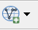

Create connection to WFS site…
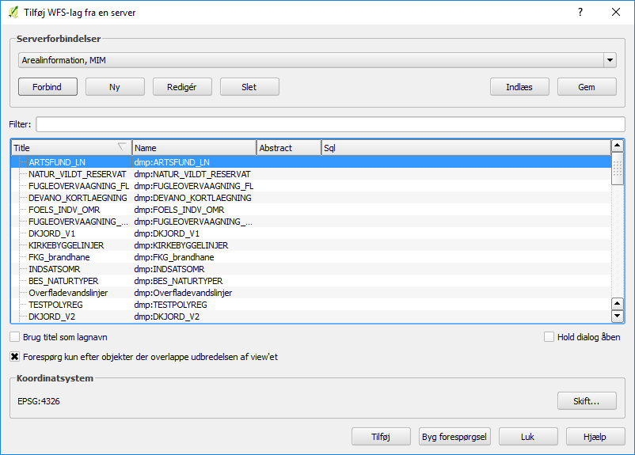

Or create new connection to WFS site…
URL is the field for WFS service endpoint url
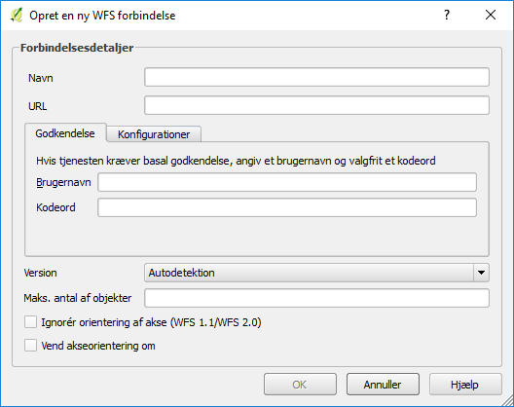
Create connection to WFS site
The layer will appear as a new layer in the layer panel.
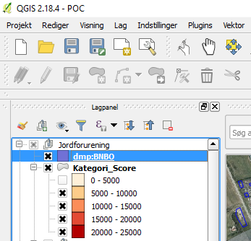
In layer panel right click on the added WFS layer, select ‘Save as…’
Select ‘ESRI Shape File’, deselect all fields (we will add new fields later) – and press ‘OK’ button
! important! – remember to set the correct projection (srid, in Denmark: 25832)
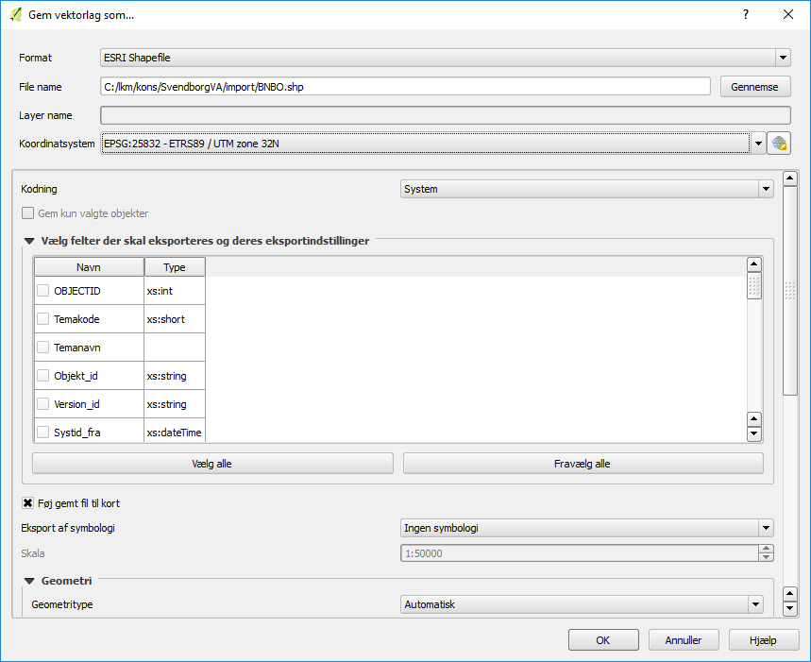

Layer is downloaded in Shape file format.

Clip layer
Clipping is used to get a smaller dataset, and improves the overall performance on the StrateGIS database.
From the QGIS Dataprocessing toolbox, select the ‘clip’ tool
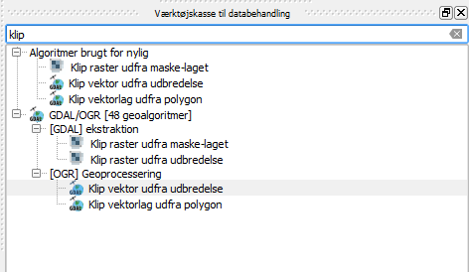
Double-click on the tool and fill out the fields. In this example, the clipping area is selected on the screen. There are other options, by selecting the ‘…’ button in the second field.
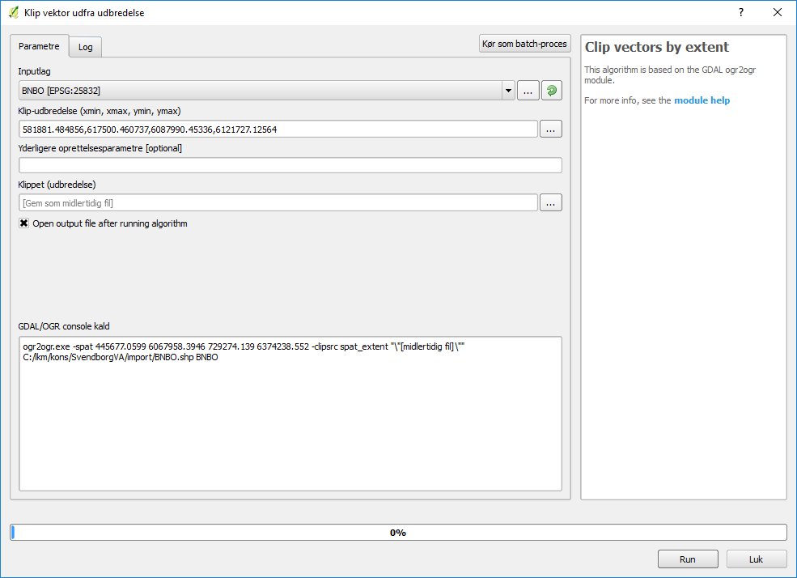
Press ‘Run’ and a new layer is processed.
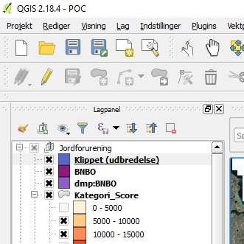

Adding score field to newly created layer
Right click on the layer in the layer panel and select ‘Open attributes’
Start editing the layer attributes, by pressing the pencil button 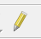
- First remove all fields: 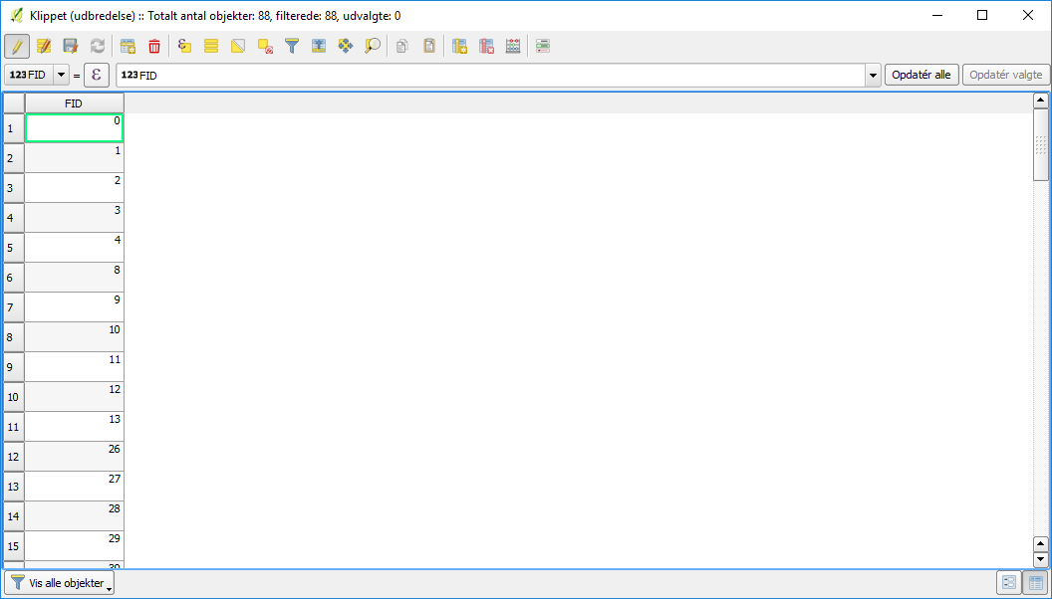 (ctrl + ‘L’)
- Next add one field ‘score’, which is a mandatory field (ctrl + ‘W’)
Edit the score attributes or use the field calculator to insert values.
When done, close the attributes window
! important! Before continuing, remember to save your edits 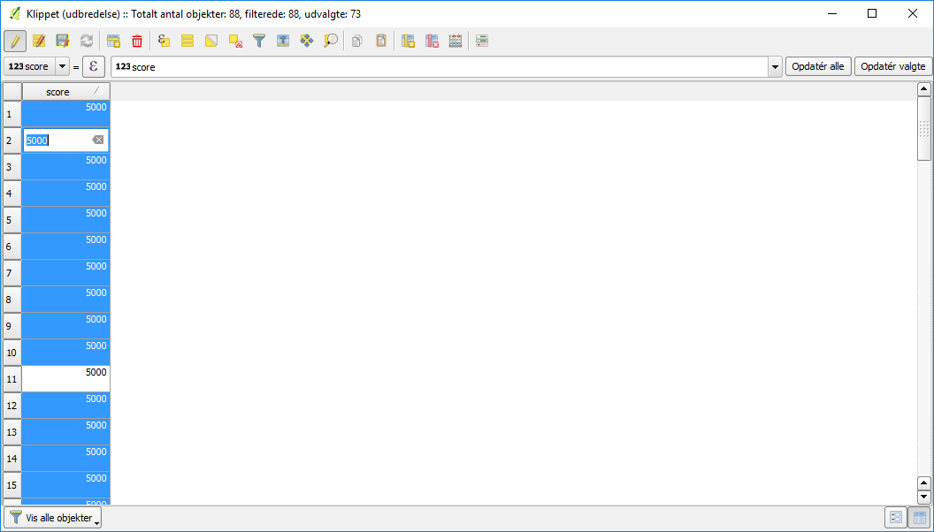 (ctrl + ‘S’).
Overwrite the original saved file – right click on the layer, choose ‘save as’ and the select the file. Please remember to walk through the settings before saving (projection, filename etc.).
Hint: If the file cannot be overwritten, it is probably because the layer still appears in the layer panel. Remove it from the layer panel and try again.

Import StrateGIS intersection layer to the database

Fill out the fields in ‘Shape file uploader’
!important! choose the correct projection, remove the ID field, adjust to the global setting for geometry name (marked with red in the illustration).
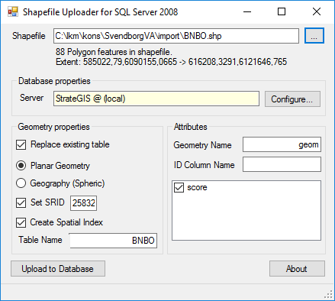

When uploaded, the intersections layer is installed in the StrateGIS database. For better performance when processing intersection rules, StrateGIS Manager has a method of pre-processing the intersection layer.
After processing the layer and the preprocessed layer is ready to use in QGIS.
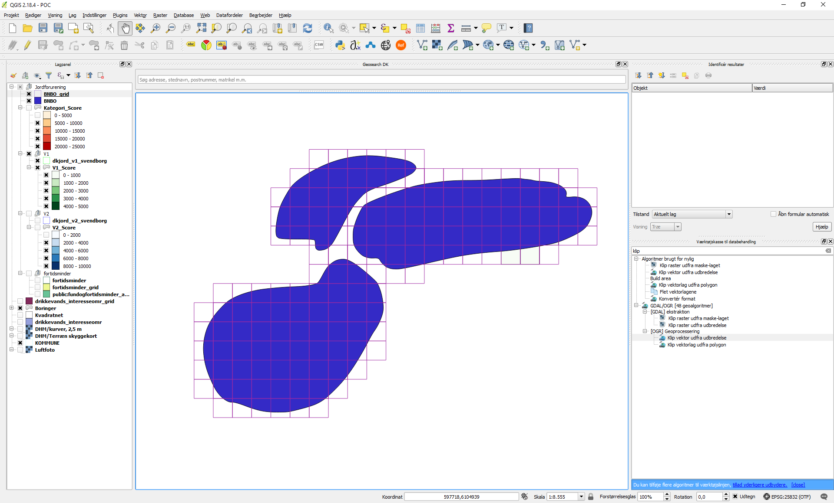

Instruction, how to download and import an Analysis layer in Strategis manager:

Please follow the instructions in ‘Instruction, how to download and import an Intersection layer in Strategis manager:’
The difference is that analysis layers has no mandatory fileds. All fields for processing analysis layers are calculated and assigned during the layer checkin process in StrateGIS Manager.

